Test of bladder cancer

# Dataset

Dataset “Three types of bladder cancer” contains 286 instances with 17,816 attributes. (<http://www.ihes.fr/~zinovyev/princmanif2006/>)

# Direct test

In this section we use our dataset with default dimensionality reduction. Times for different operation are presented in Table 1. Column “Time spent (s)” means time spent in original version.

Table 1. Times for separate operations (DR means dimensionality reduction)

|  |  |
| --- | --- |
| Operation | Time spent (s) |
| Map initialisation | 0.034016 |
| drawMap | 0.334594 |
| Fitting map1 'stretch', 0.01, 'bend', 0.1 | 0.006926 |
| Fitting map2 'stretch', 0.01, 'bend', 1 | 0.049439 |
| Fitting map2 'stretch', 0, 'bend', 1 continuation | 0.005016 |
| Fitting map2 'stretch', 0, 'bend', 0.5 continuation | 0.003840 |
| Fitting map2 'stretch', 0, 'bend', 0.1 continuation | 0.006667 |
| Fitting map3 'stretch', 0.01, 'bend', 1 | 0.030187 |
| Fitting map3 'stretch', 0, 'bend', 1 continuation | 0.019047 |
| Fitting map3 'stretch', 0, 'bend', 0.5 continuation | 0.007038 |
| Fitting map3 'stretch', 0, 'bend', 0.1 continuation | 0.005631 |
| Fitting map4 'stretch', 0.01, 'bend', 1 | 0.043014 |
| Fitting map4 'stretch', 0, 'bend', 1 continuation | 0.007143 |
| Fitting map4 'stretch', 0, 'bend', 0.5 continuation | 0.007274 |
| Fitting map4 'stretch', 0, 'bend', 0.1 continuation | 0.007410 |
| Internal projection to nodes map 1 | 0.240064 |
| Internal projection to nodes map 2 | 0.312912 |
| Internal projection to edges map 1 | 0.115541 |
| Internal projection to edges map 2 | 0.196807 |
| Internal projection to faces map 1 | 0.118485 |
| Internal projection to faces map 2 | 0.255333 |

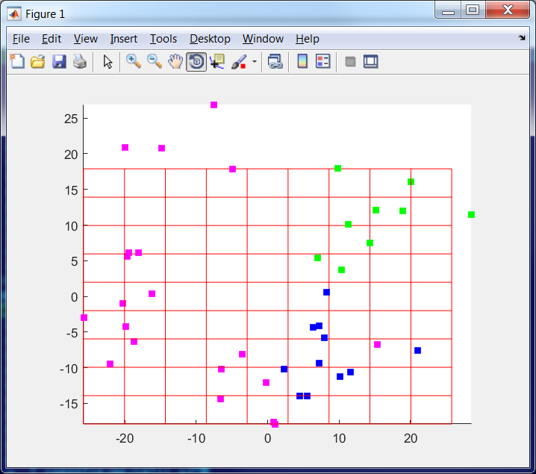 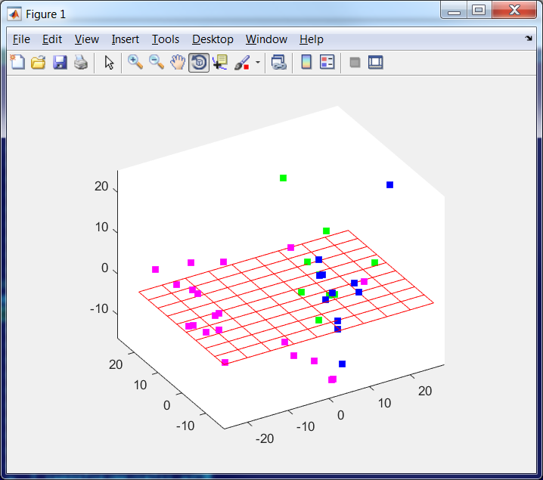

Figure 1. Data points in the space of the first two PCs (left) and first three PCs (right)

Result of the first strategy of map training is presented in Figure 2. This map is called map1.

a 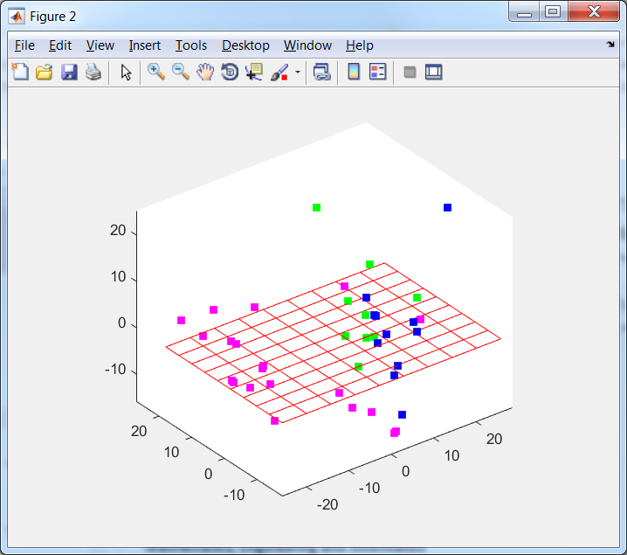 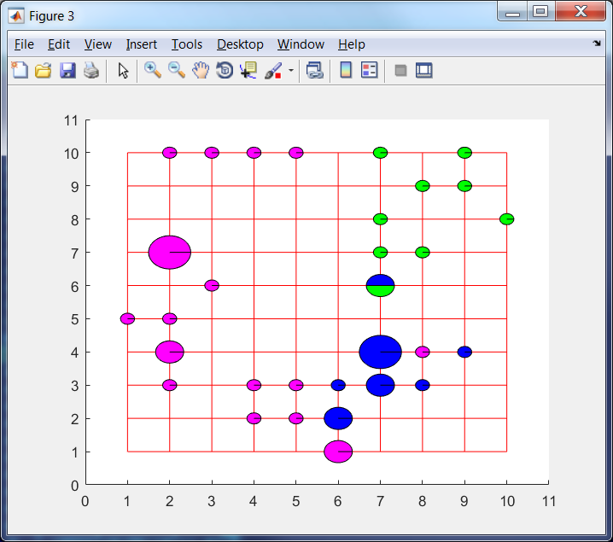 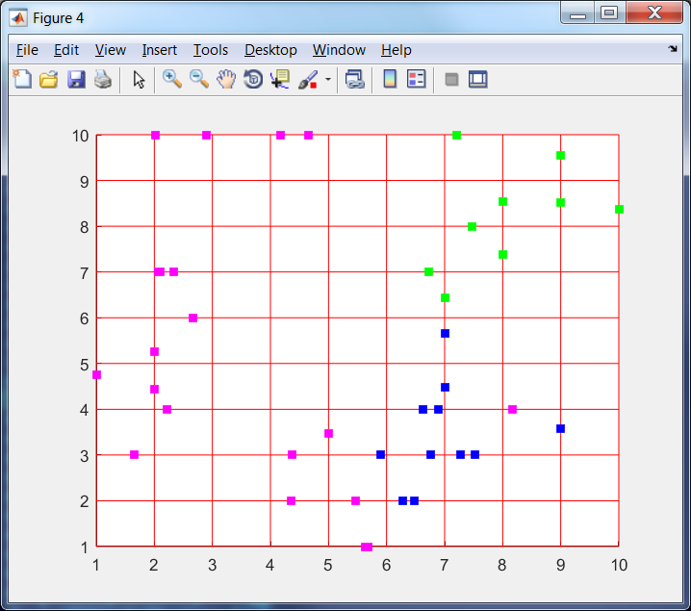 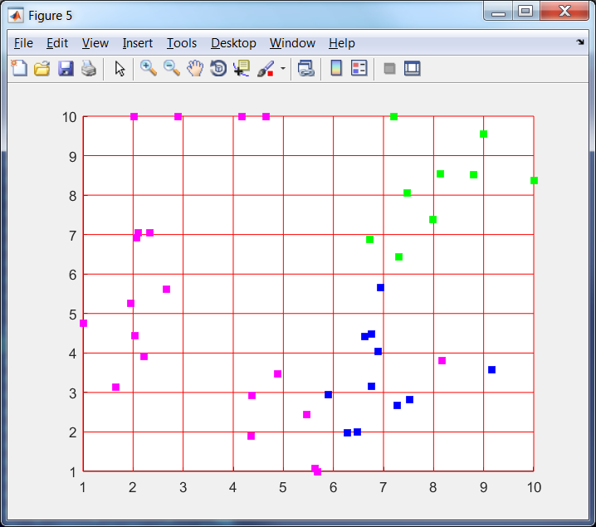

b 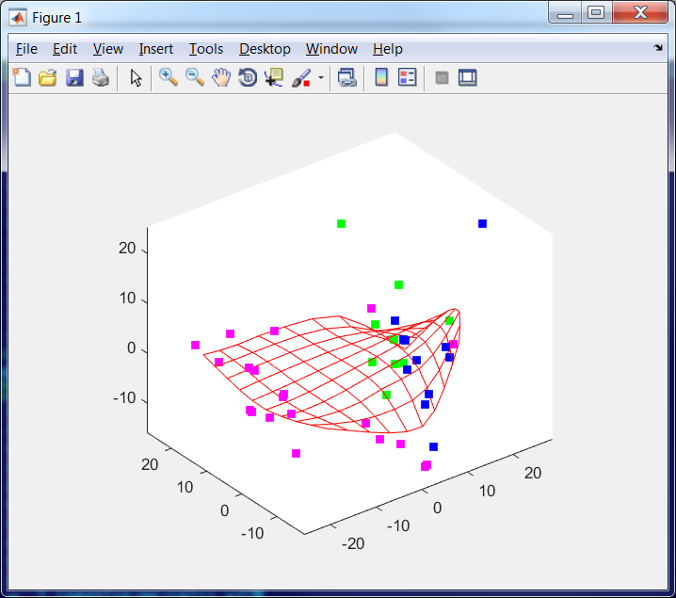 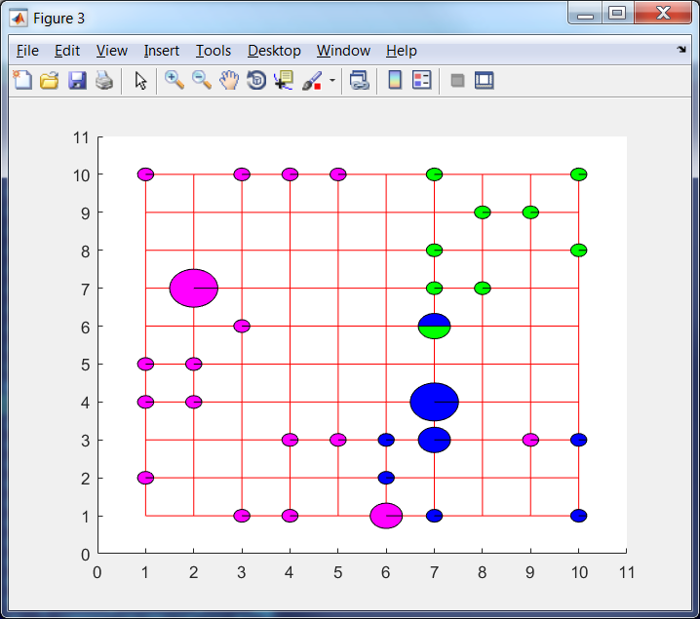 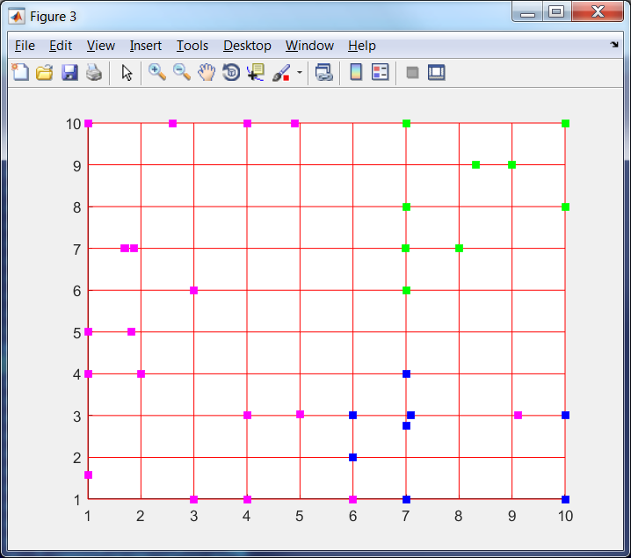 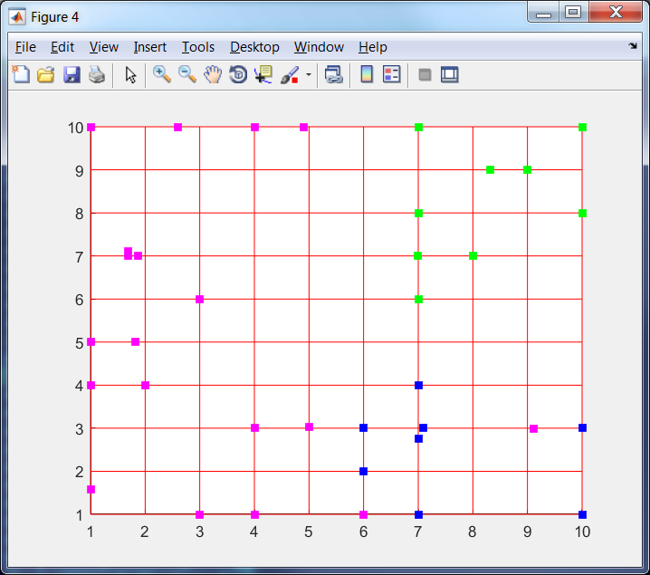

c 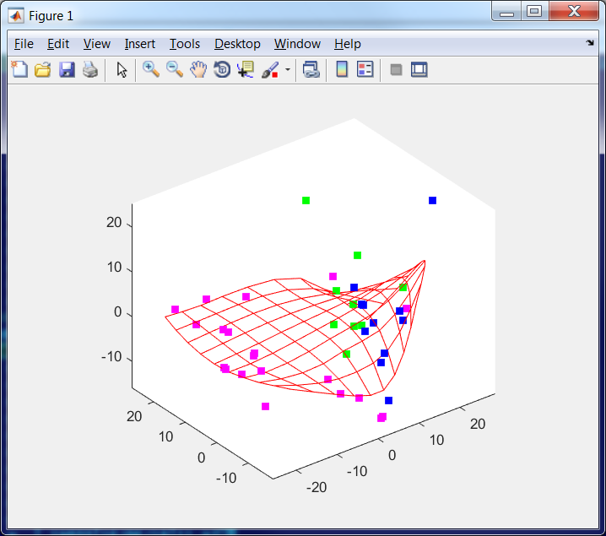 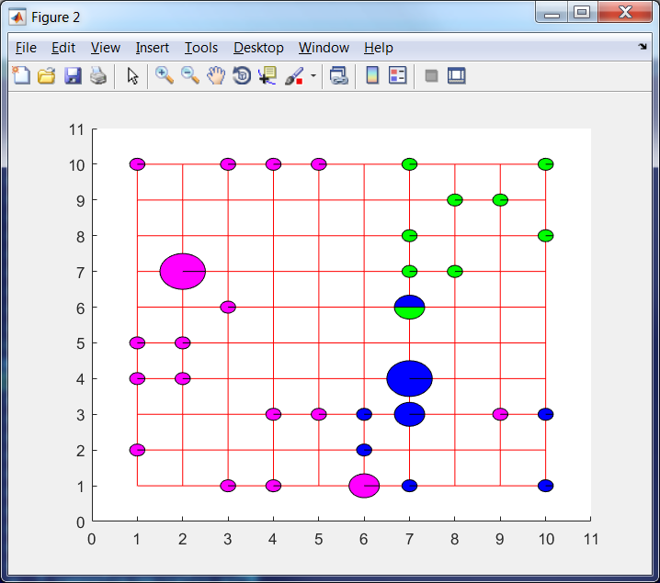 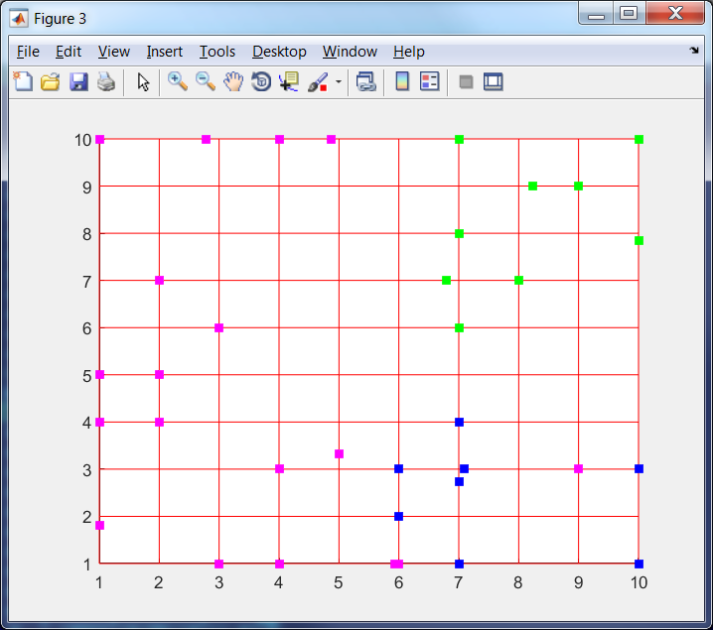 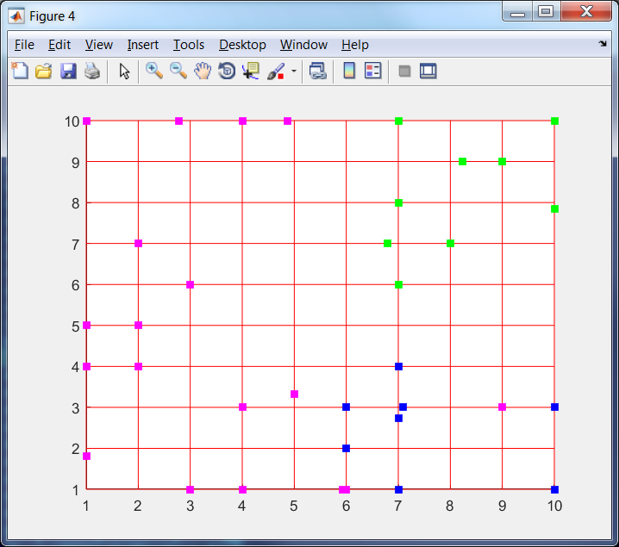

d 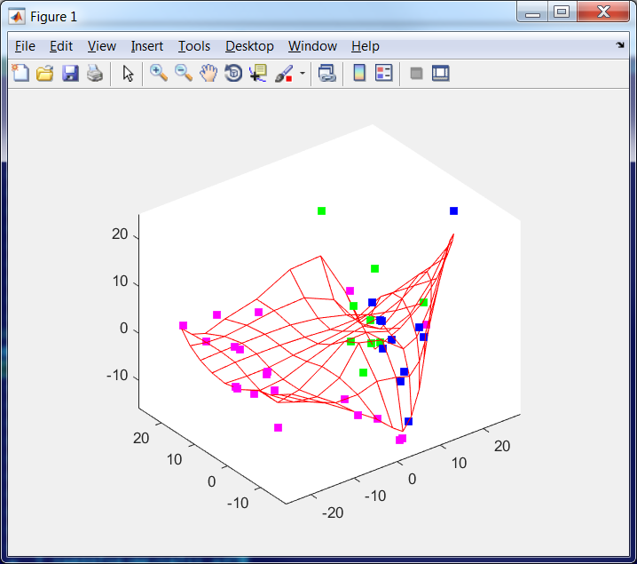  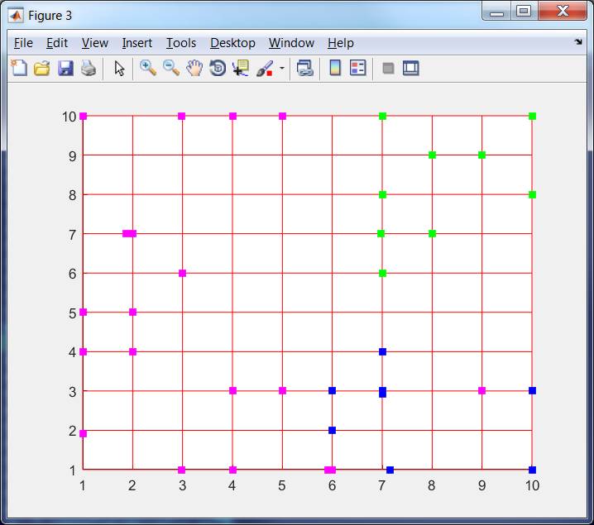 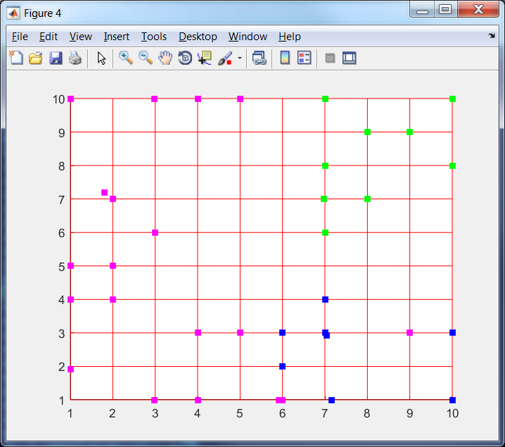

e 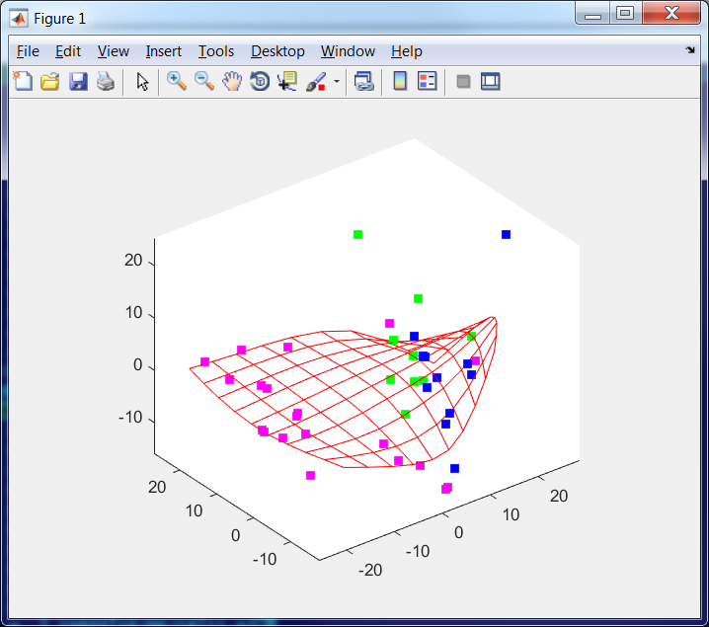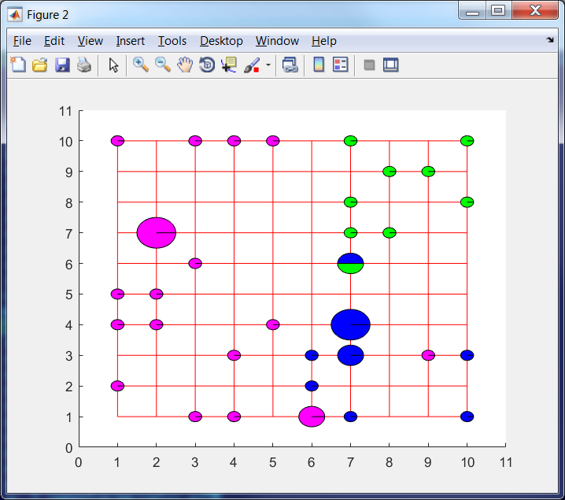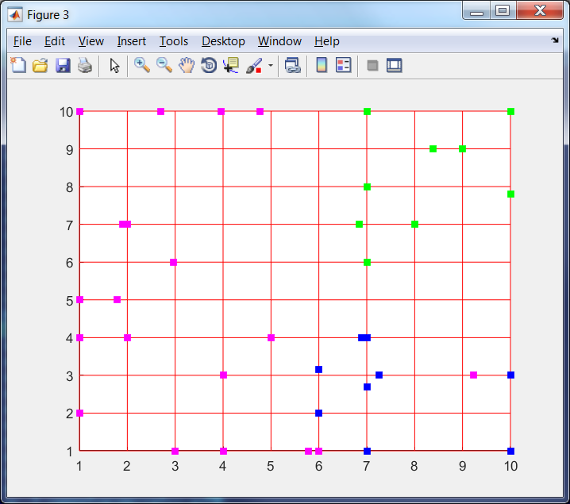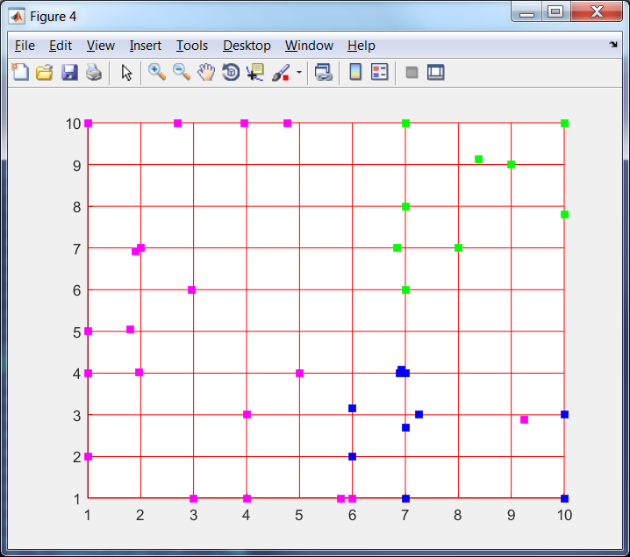

f 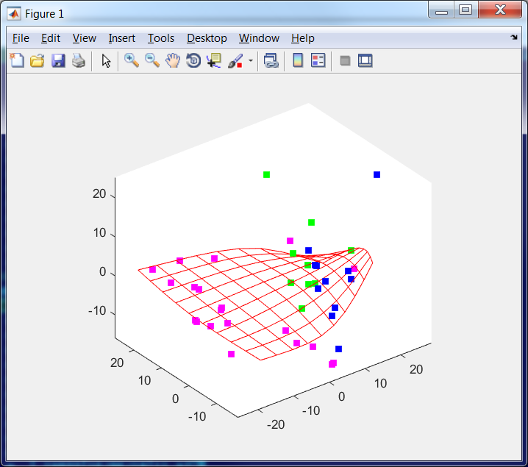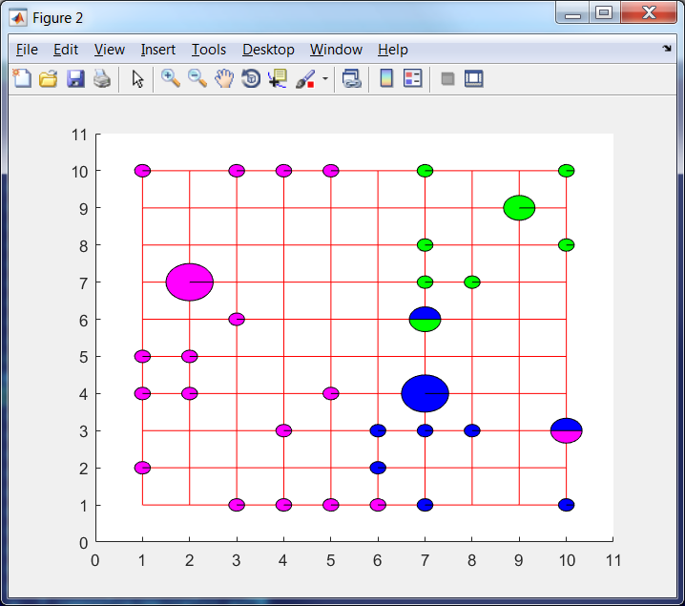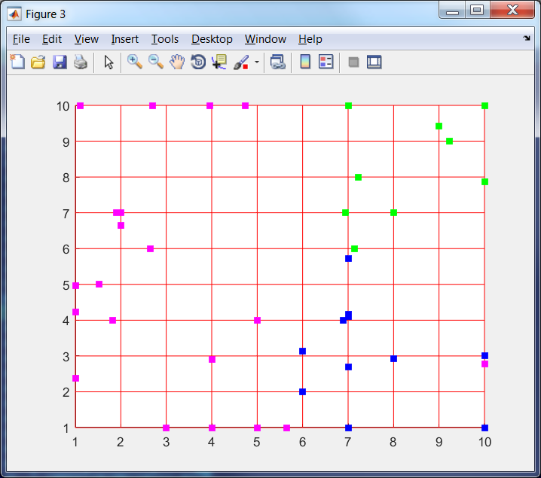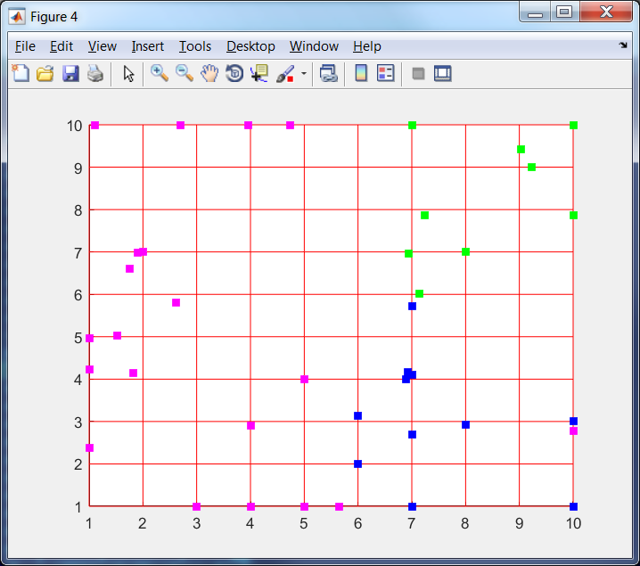

Figure 2. Fitting of ElMap without restart for (top down) with (left to right) 3D image, projection onto nodes, onto edges and onto faces; a – without training; b – 'stretch', 0.01, 'bend', 0.1; c – 'stretch', 0, 'bend', 0.1; d – 'stretch', 0, 'bend', 0.01; e – 'stretch', 0, 'bend', 0.2; f – 'stretch', 0, 'bend', 0.5

The next experiment is attempt to form map by other trajectory: originally we use stronger parameters and then will soften it. Results are presented in Figure 3. This map is called map 2.

a    

b 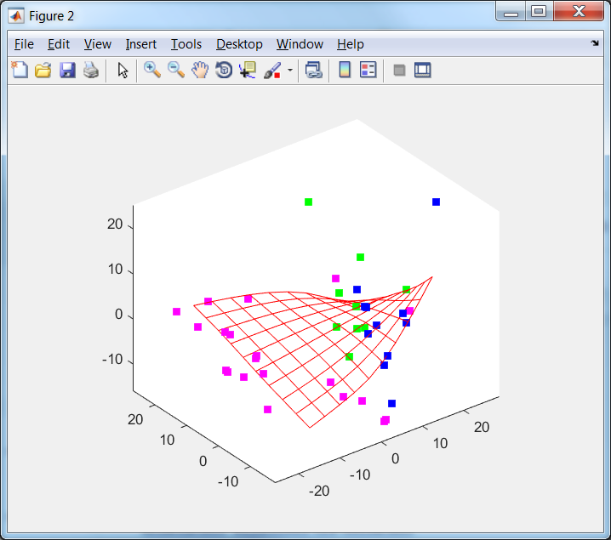 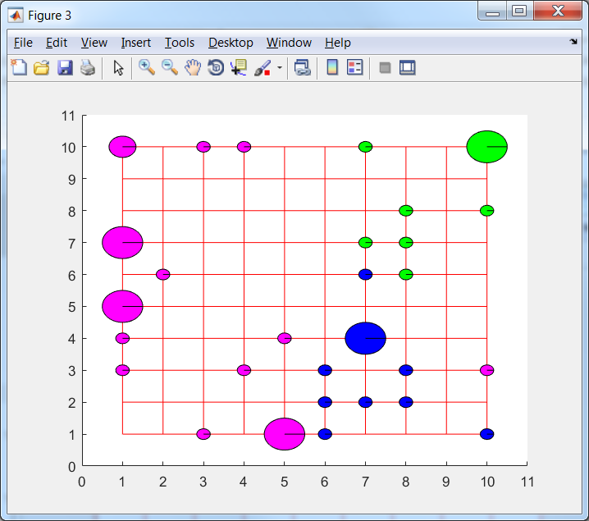 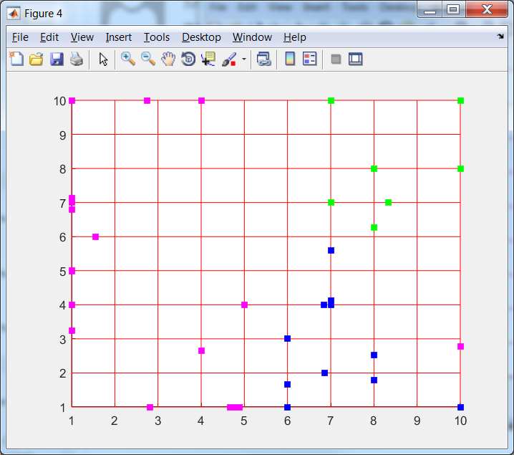 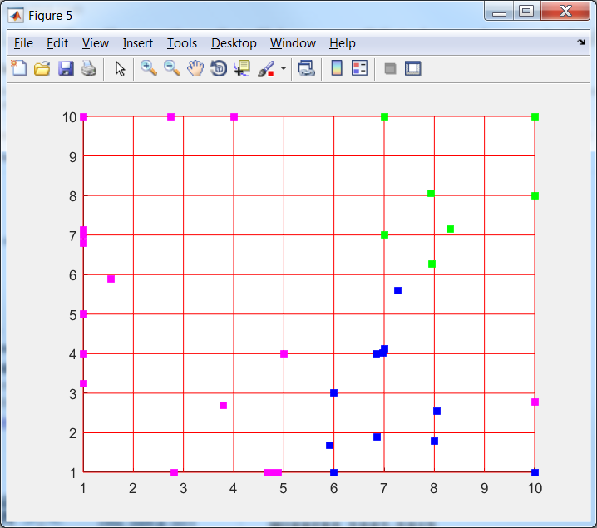

c 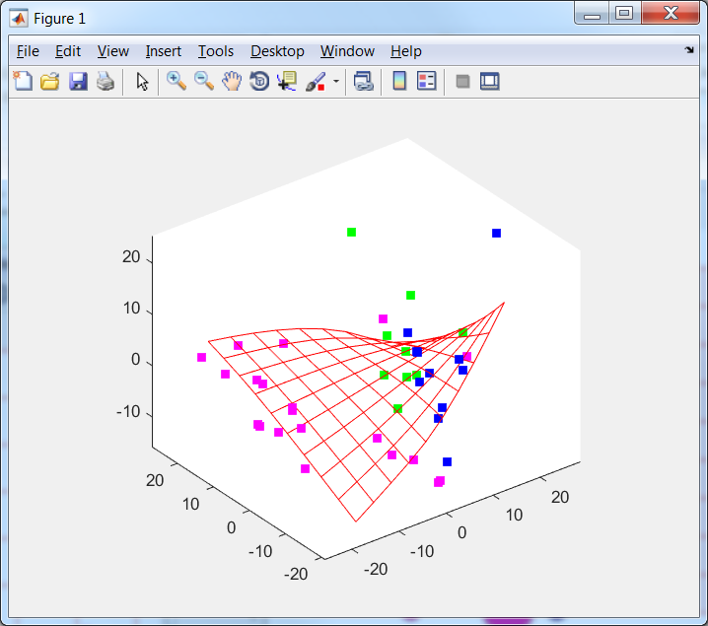 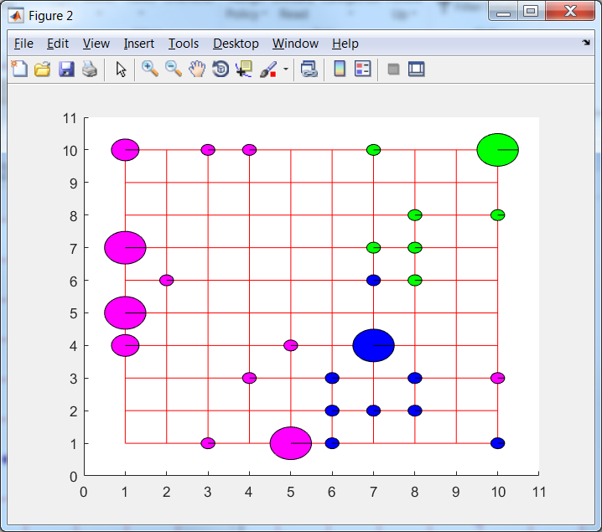 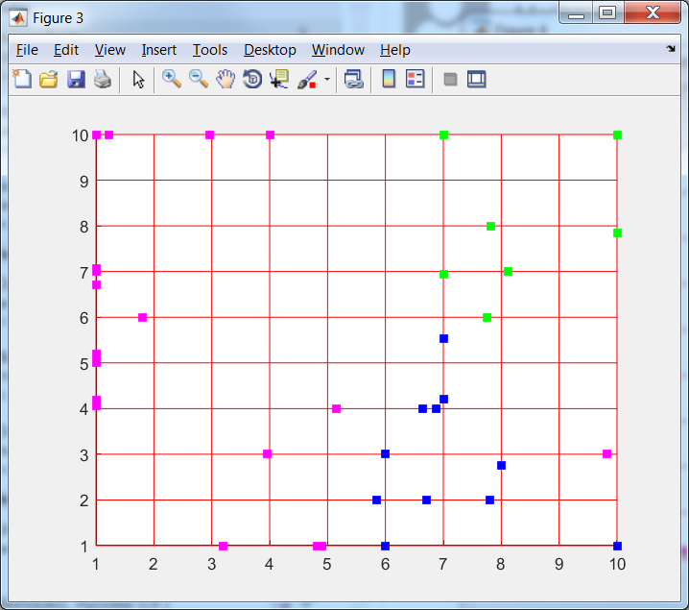 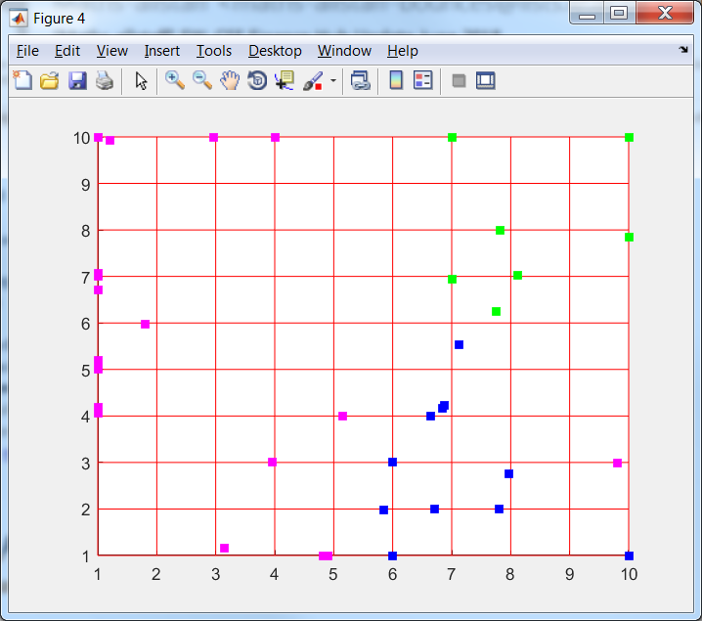

d 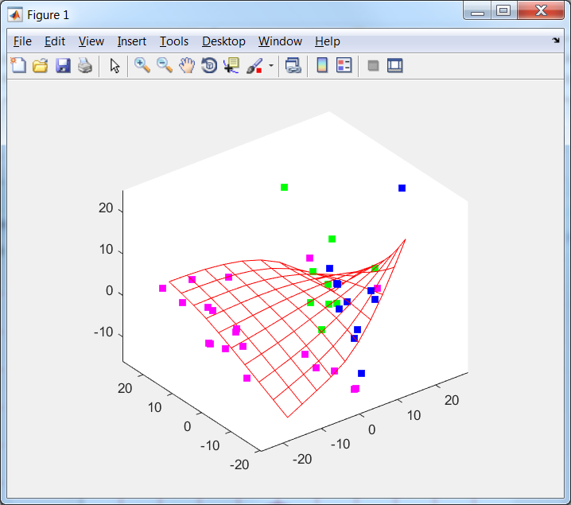 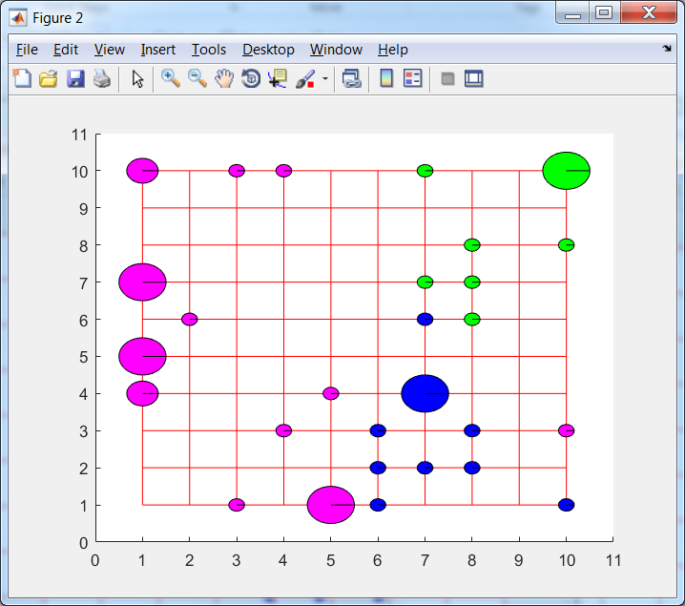 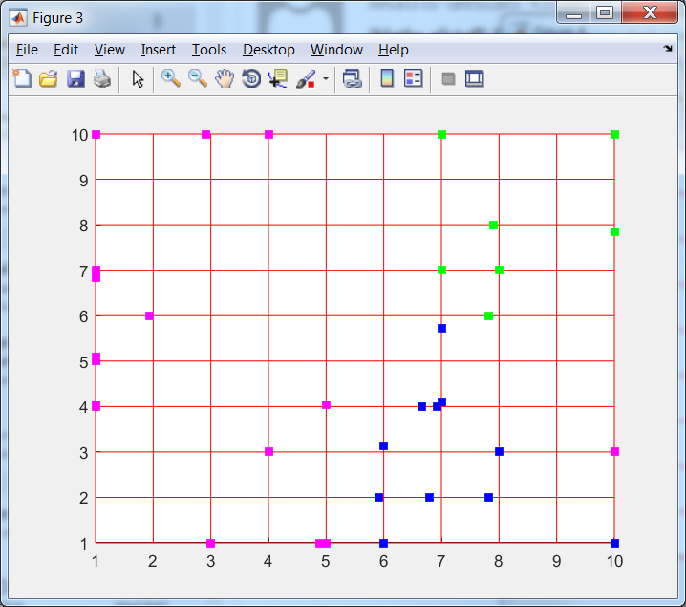 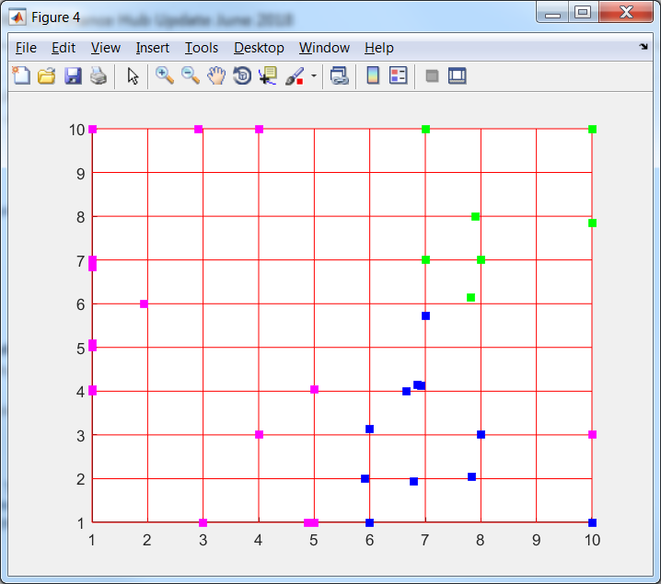

e 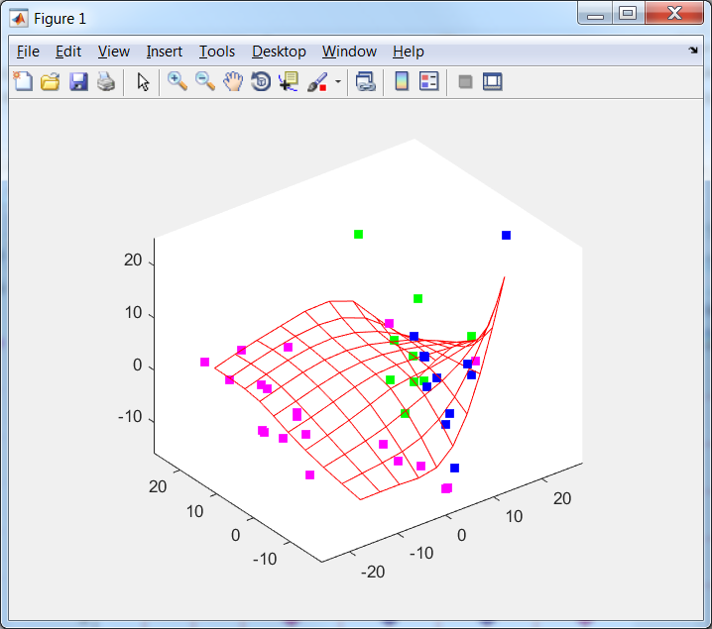 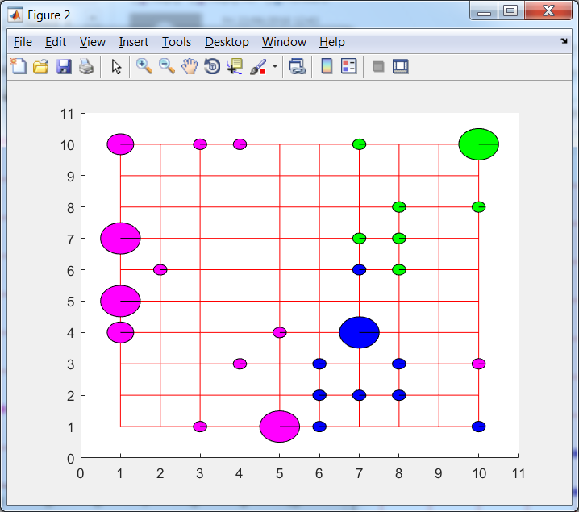 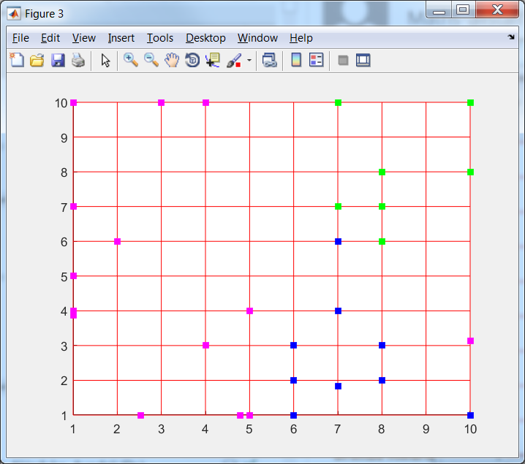 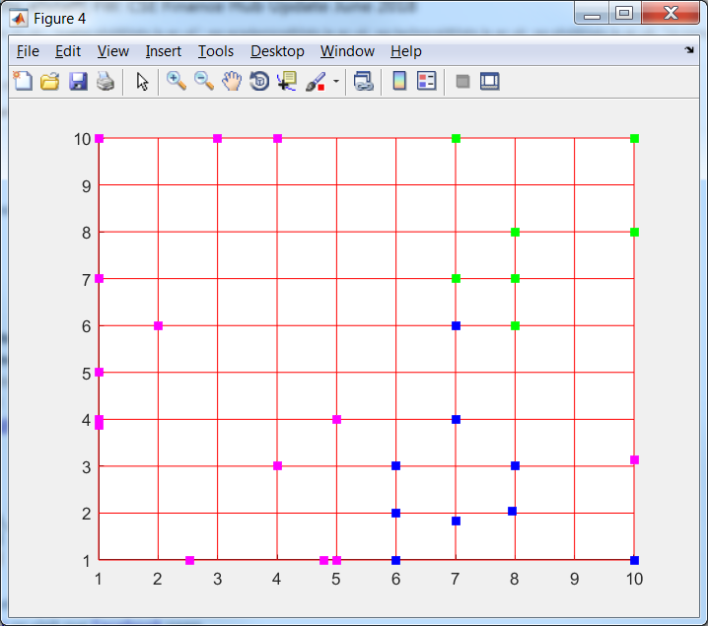

Figure 3. Fitting of ElMap without restart for with (left to right) 3D image, projection onto nodes, onto edges and onto faces; a – without training; b – 'stretch', 0.01, 'bend', 1; c – 'stretch', 0, 'bend', 1; d – 'stretch', 0, 'bend', 0.5; e – 'stretch', 0, 'bend', 0.1

The next experiment uses the same series of modules but with PQSQ L1 data attraction. This map is called map3.

a    

b 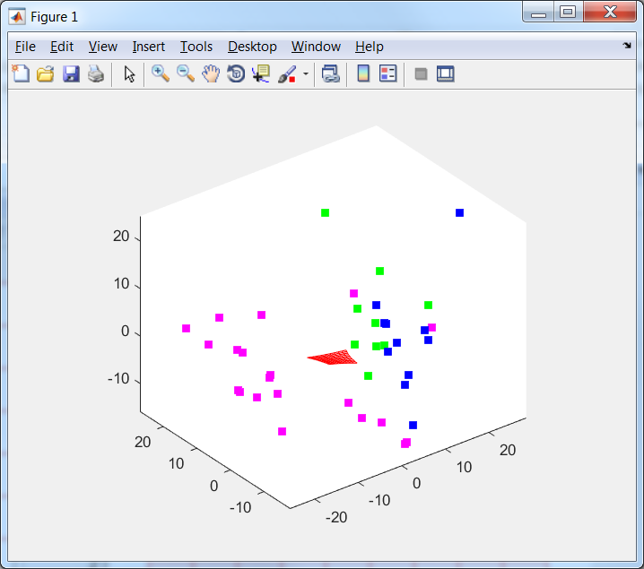 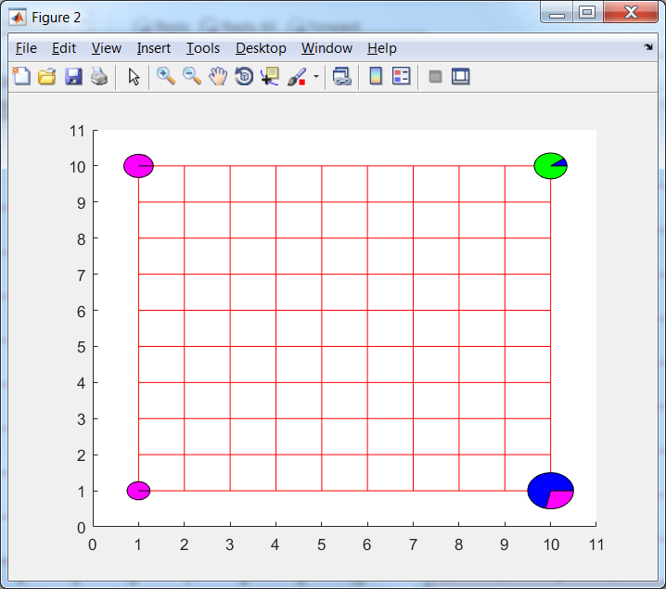 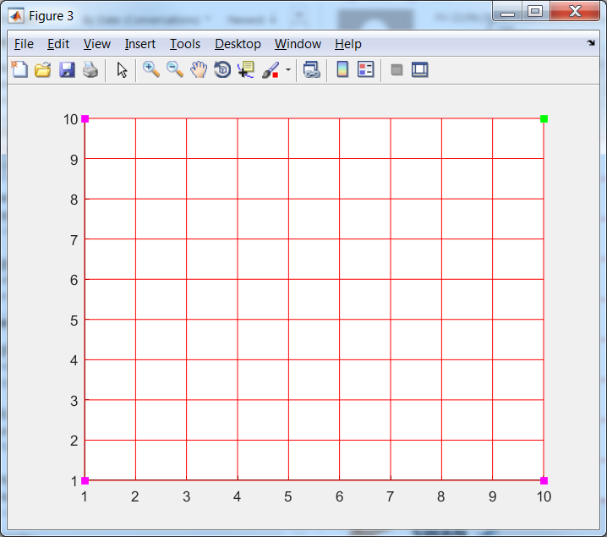 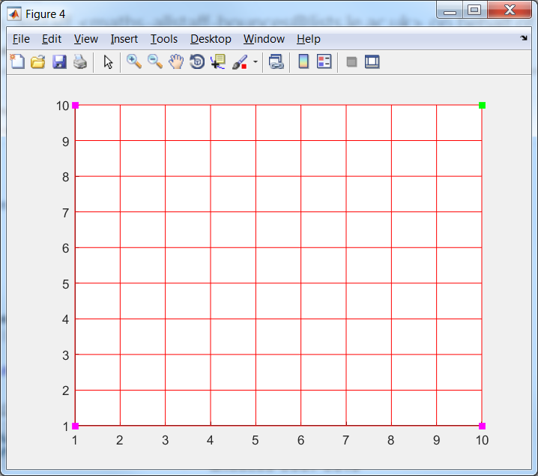

c 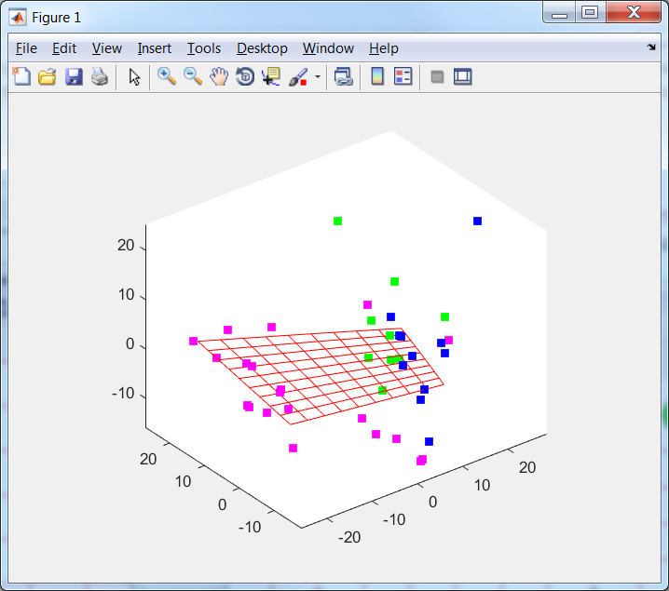 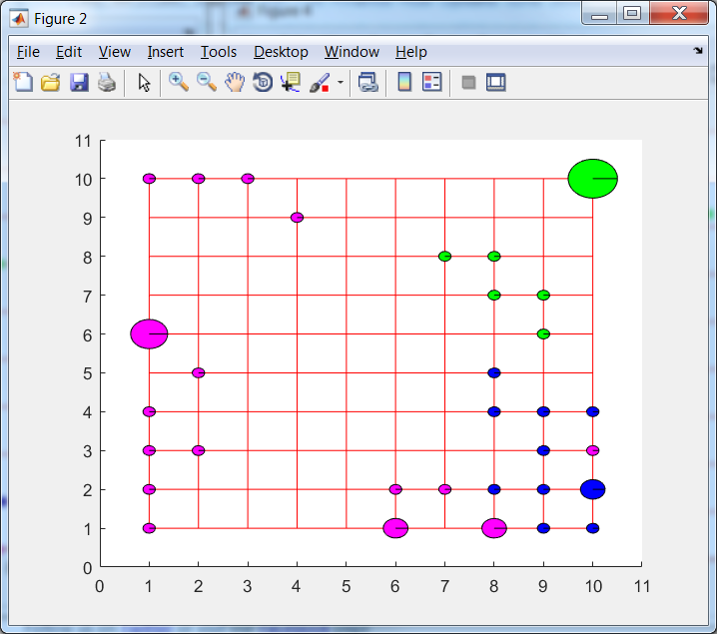 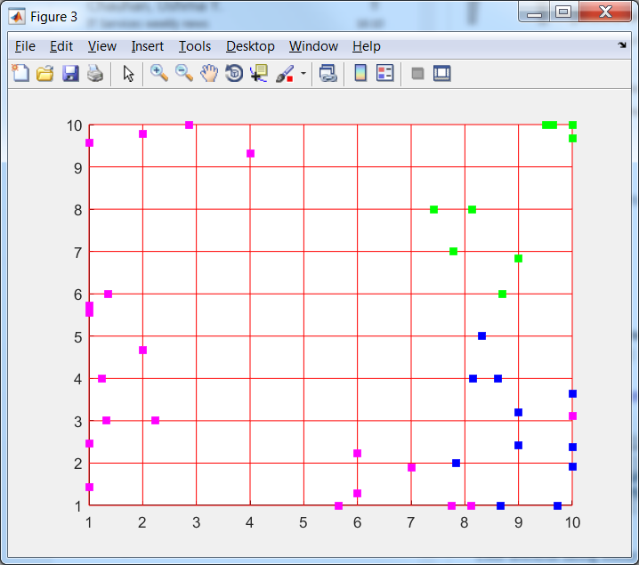 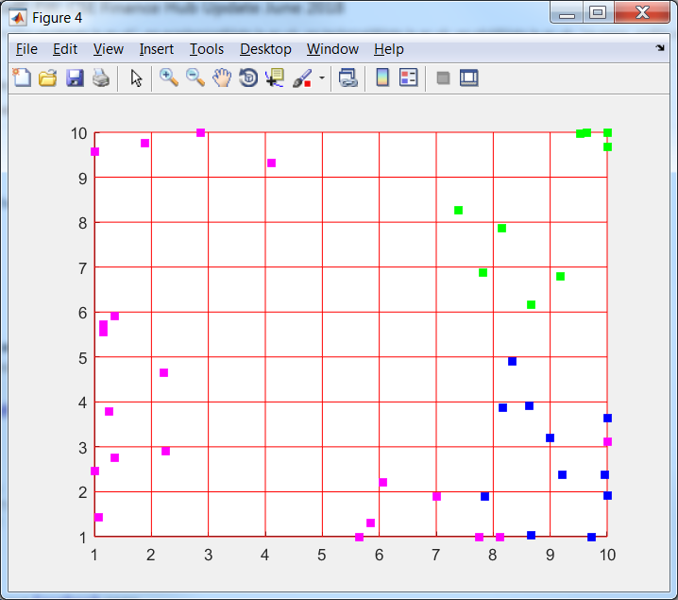

d 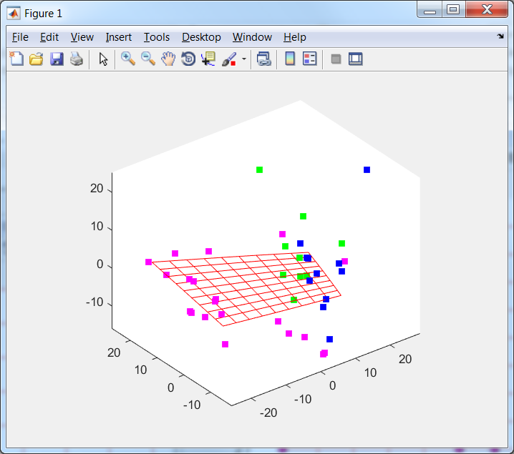 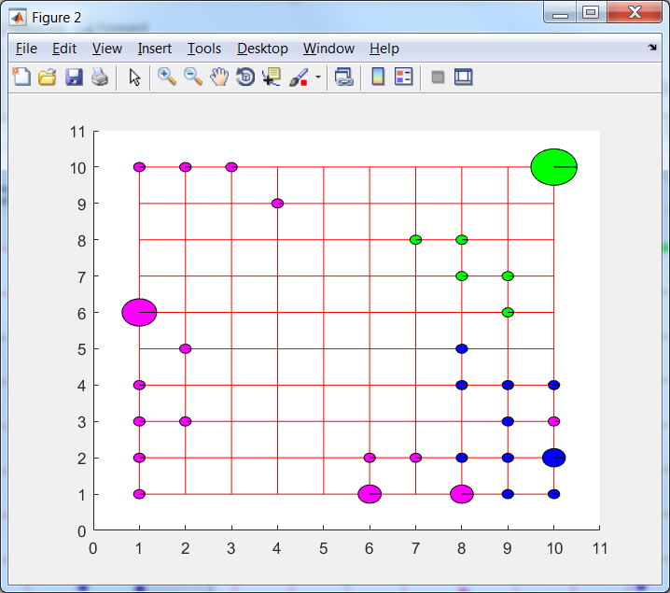 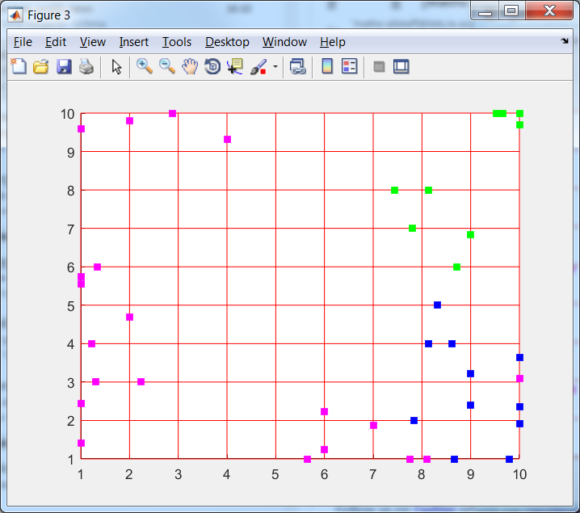 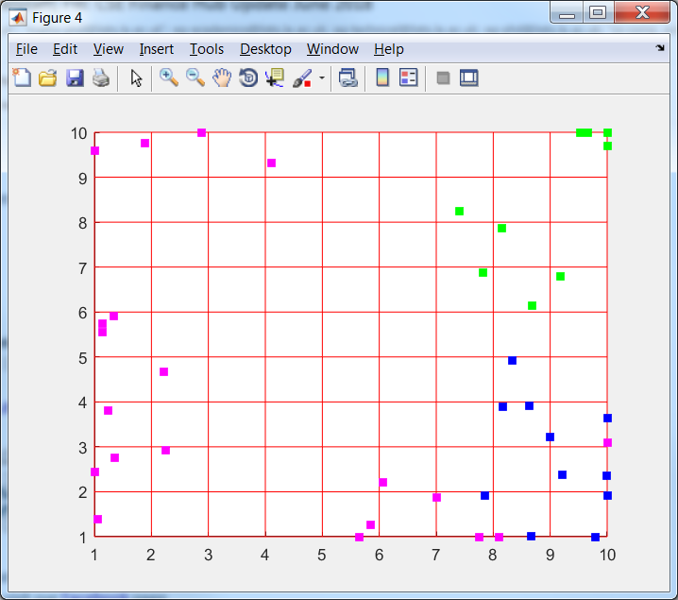

e 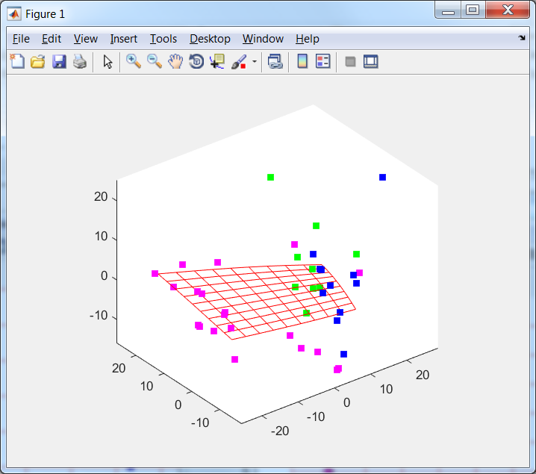 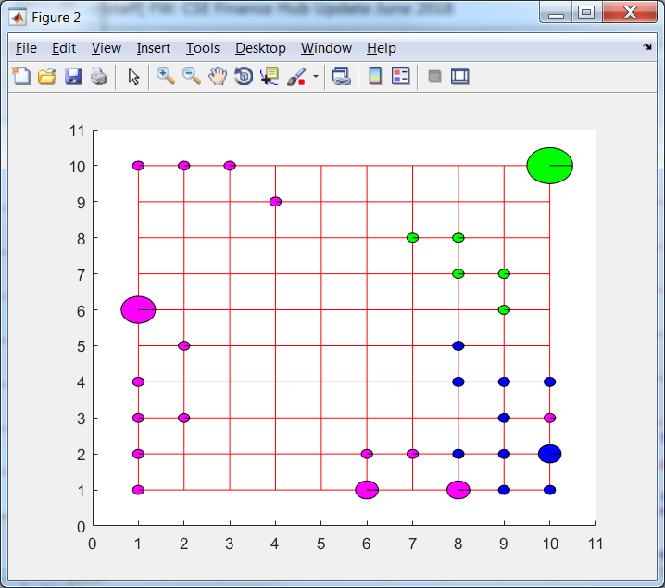 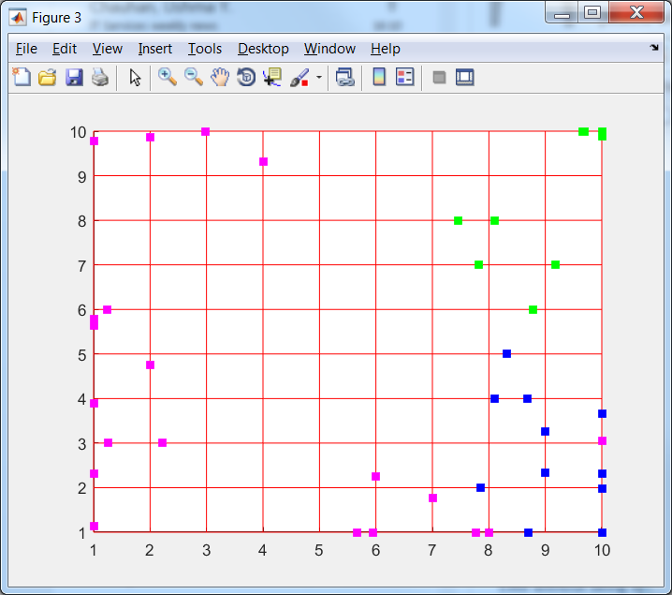 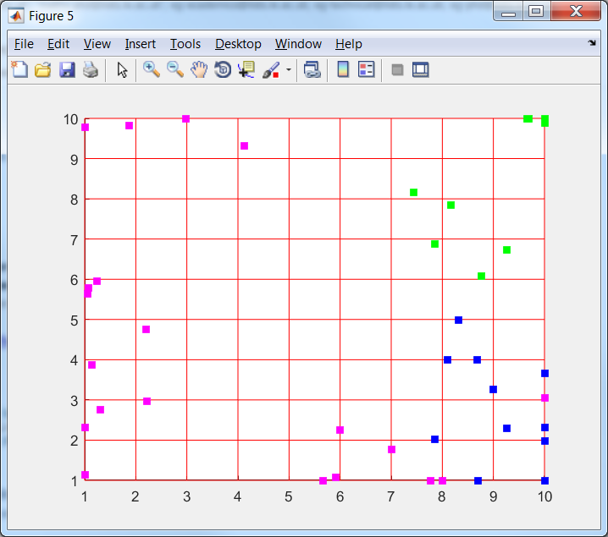

Figure 4. Fitting of ElMap without restart for with (left to right) 3D image, projection onto nodes, onto edges and onto faces, data attraction defined as 'potential', @L1, 'Number_of_intervals', 5; a – without training; b – 'stretch', 0.01, 'bend', 1; c – 'stretch', 0, 'bend', 1; d – 'stretch', 0, 'bend', 0.5; e – 'stretch', 0, 'bend', 0.1

The next experiment uses the same series of modules but with PQSQ L2 data attraction with trimming. This map is called map4.

a    

b 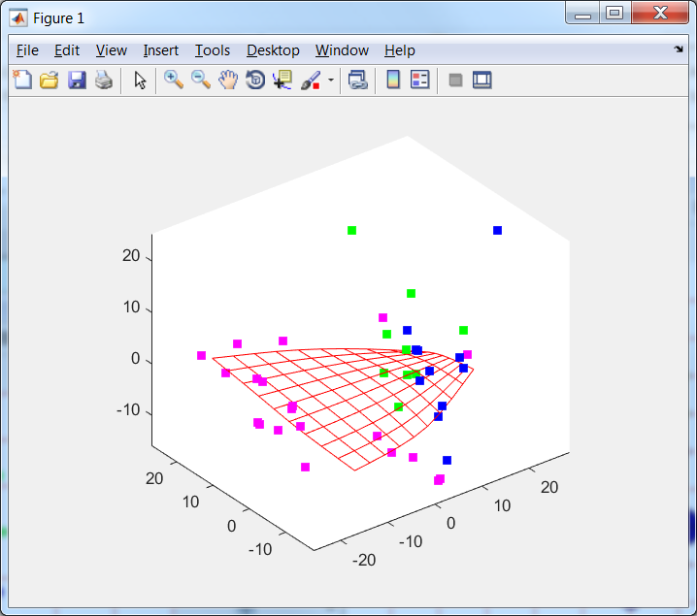 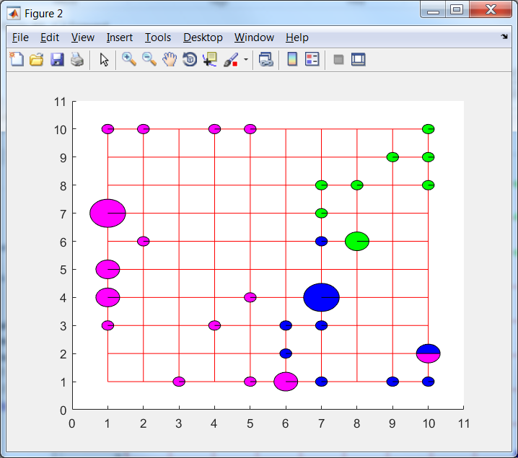 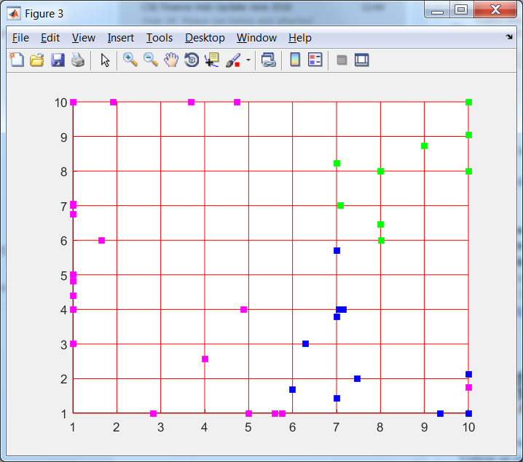 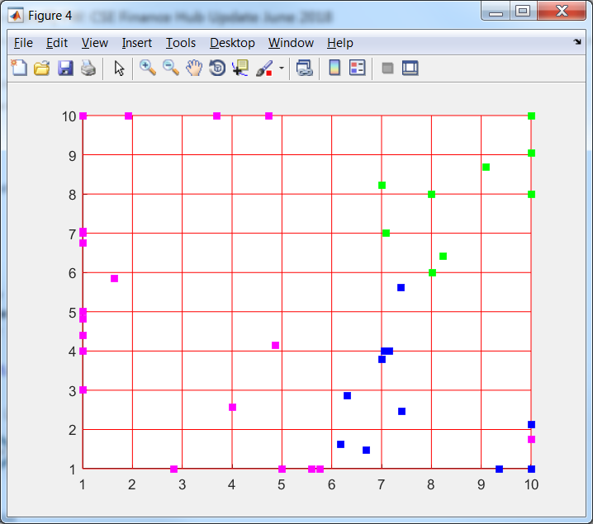

c 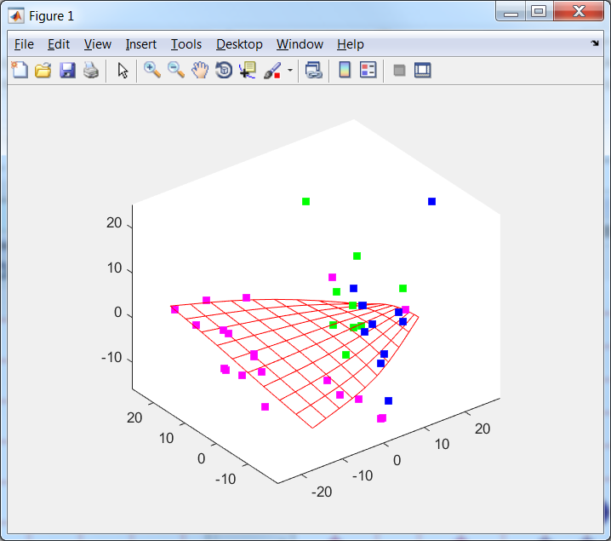 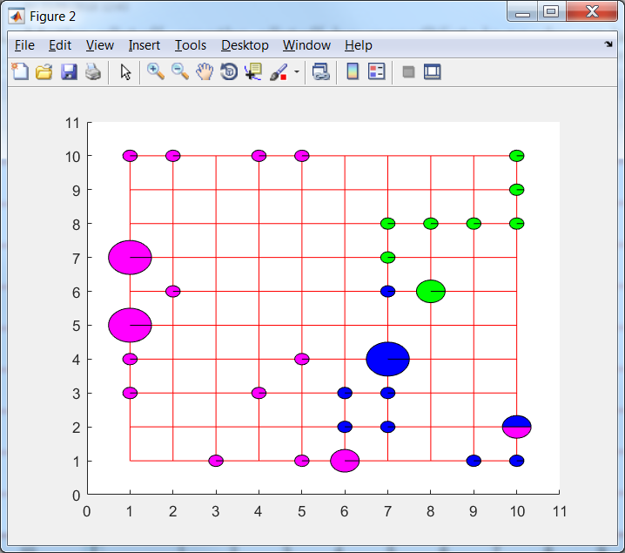 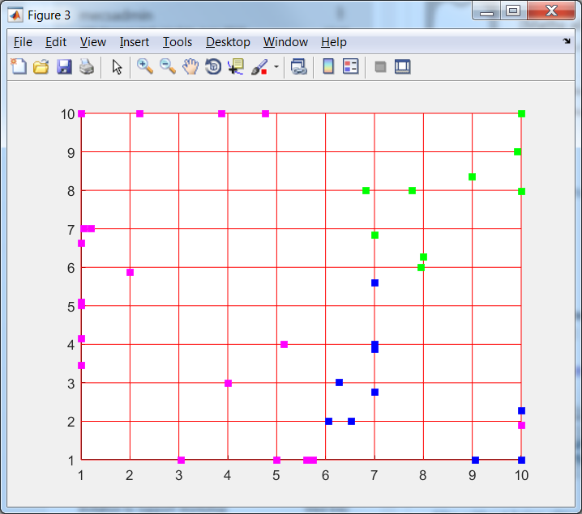 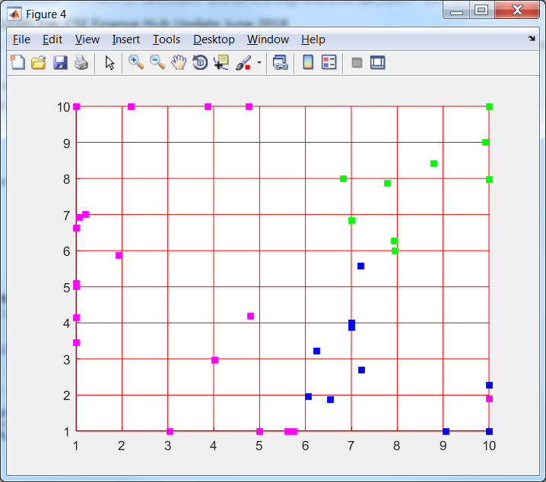

d 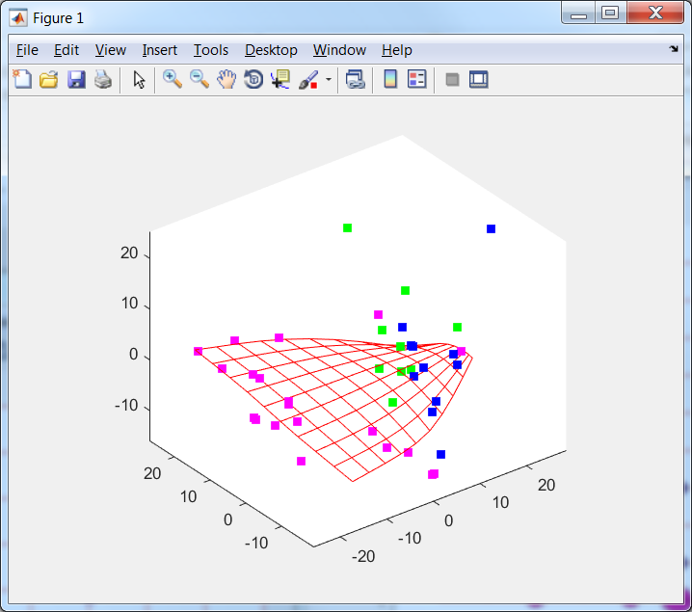 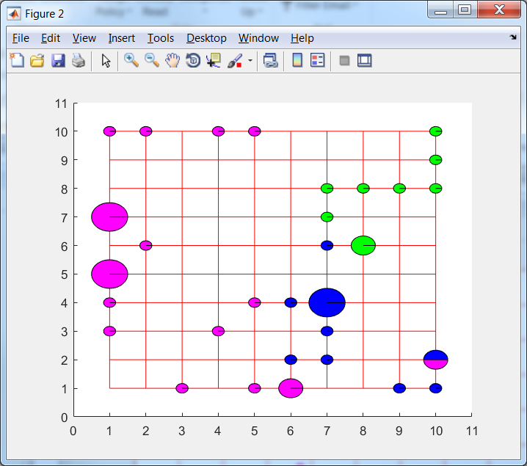 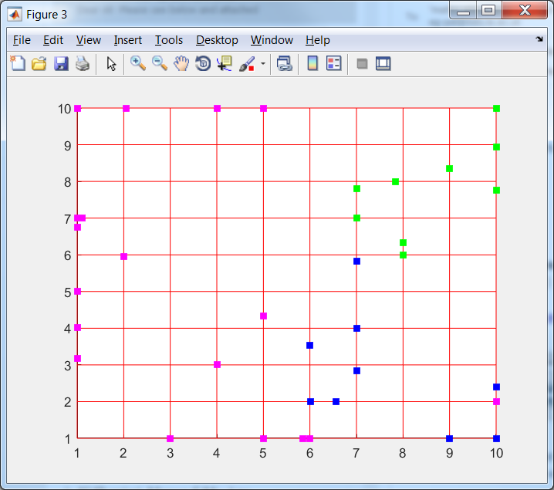 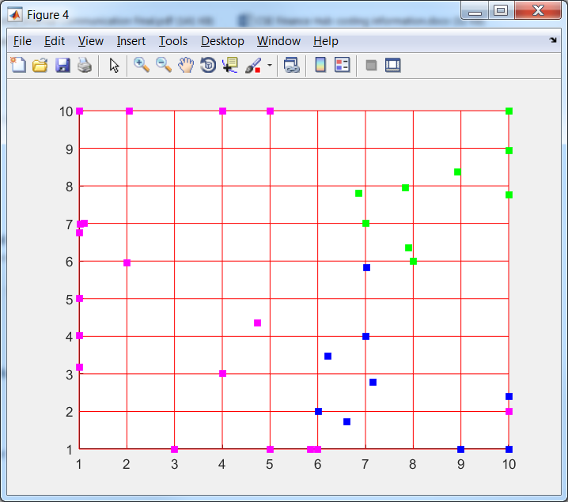

e 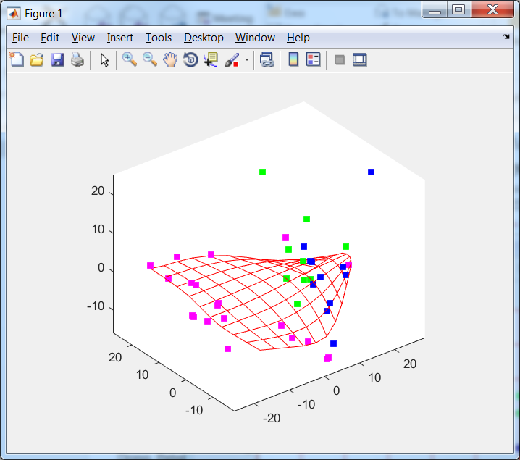 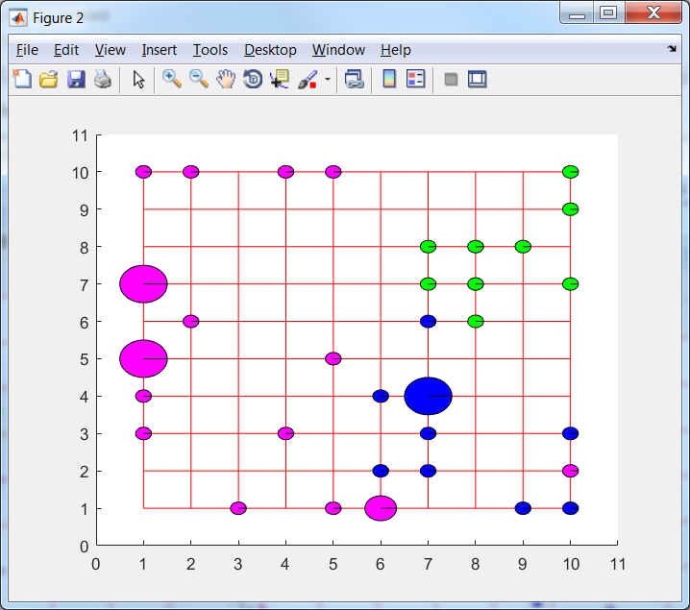 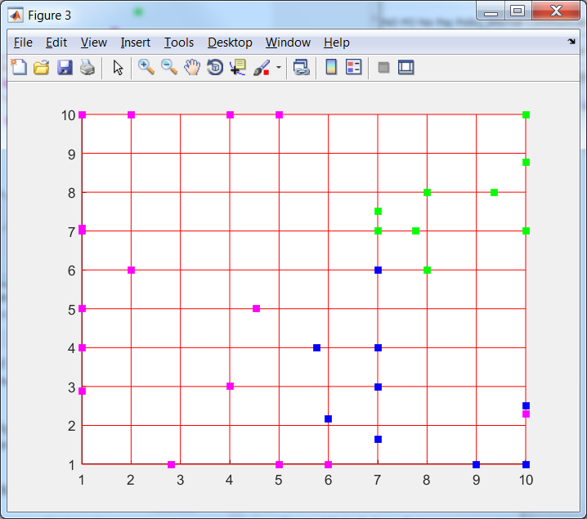 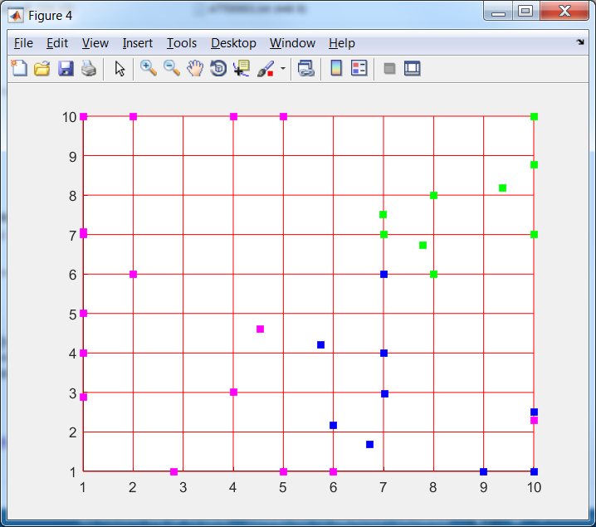

Figure 5. Fitting of ElMap without restart for with (left to right) 3D image, projection onto nodes, onto edges and onto faces, data attraction defined as 'potential', @L2, 'Number_of_intervals', 2, 'intshrinkage', 0.75; a – without training; b – 'stretch', 0.01, 'bend', 1; c – 'stretch', 0, 'bend', 1; d – 'stretch', 0, 'bend', 0.5; e – 'stretch', 0, 'bend', 0.1

# Comparison of four maps

The finale state of four formed maps are presented in Table 2. All four maps show three groups of points and one outlier in magenta. Maps 1, 2 and 4 show the two groups of points in blue. Maps 1, 2 and 3 shows two groups in green.

Maps 2, 3 and 4 completely separate blue and green (there is no node with two points of different types which are associated with this node).

Table 2. Comparison of four maps

|  |  |  |
| --- | --- | --- |
| Map | 3D | Projection onto nodes |
| Map 1 |  |  |
| Map 2 |  |  |
| Map 3 |  |  |
| Map 4 |  |  |